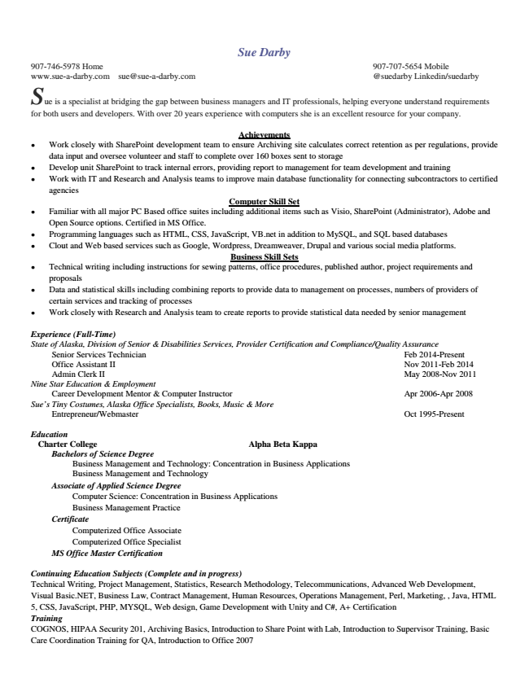

Sue Darby 907-746-5978 Home 907-707-5654 Mobile www.sue-a-darby.com sue@sue-a-darby.com @suedarby Linkedin/suedarby S

ue is a specialist at bridging the gap between business managers and IT professionals, helping everyone understand requirements for both users and developers. With over 20 years experience with computers she is an excellent resource for your company.

**Achievements**

● Work closely with SharePoint development team to ensure Archiving site calculates correct retention as per regulations, provide data input and oversee volunteer and staff to complete over 160 boxes sent to storage

● Develop unit SharePoint to track internal errors, providing report to management for team development and training

● Work with IT and Research and Analysis teams to improve main database functionality for connecting subcontractors to certified agencies

**Computer Skill Set**

● Familiar with all major PC Based office suites including additional items such as Visio, SharePoint (Administrator), Adobe and Open Source options. Certified in MS Office.

● Programming languages such as HTML, CSS, JavaScript, VB.net in addition to MySQL, and SQL based databases

● Clout and Web based services such as Google, Wordpress, Dreamweaver, Drupal and various social media platforms.

**Business Skill Sets**

● Technical writing including instructions for sewing patterns, office procedures, published author, project requirements and proposals

● Data and statistical skills including combining reports to provide data to management on processes, numbers of providers of certain services and tracking of processes

● Work closely with Research and Analysis team to create reports to provide statistical data needed by senior management

*Experience (Full-Time) State of Alaska, Division of Senior & Disabilities Services, Provider Certification and Compliance/Quality Assurance*

Senior Services Technician Feb 2014-Present Office Assistant II Nov 2011-Feb 2014 Admin Clerk II May 2008-Nov 2011 Nine Star Education & Employment

*Career Development Mentor & Computer Instructor Apr 2006-Apr 2008 Sue’s Tiny Costumes, Alaska Office Specialists, Books, Music & More*

Entrepreneur/Webmaster Oct 1995-Present

***Education***

**Charter College Alpha Beta Kappa**

***Bachelors of Science Degree***

Business Management and Technology: Concentration in Business Applications Business Management and Technology Associate of Applied Science Degree

Computer Science: Concentration in Business Applications Business Management Practice Certificate

Computerized Office Associate Computerized Office Specialist MS Office Master Certification

Continuing Education Subjects (Complete and in progress) Technical Writing, Project Management, Statistics, Research Methodology, Telecommunications, Advanced Web Development, Visual Basic.NET, Business Law, Contract Management, Human Resources, Operations Management, Perl, Marketing, , Java, HTML 5, CSS, JavaScript, PHP, MYSQL, Web design, Game Development with Unity and C#, A+ Certification Training COGNOS, HIPAA Security 201, Archiving Basics, Introduction to Share Point with Lab, Introduction to Supervisor Training, Basic Care Coordination Training for QA, Introduction to Office 2007